Lesson 02 - Sailing without a Rudder
Many small-boat sailors don't realize the importance of using weight placement, sail trim, and boat trim to help steer their boat. They assume that the steering is accomplished with the rudder - that's what it's there for, right? However, smart sailors realize that their boat will go faster if they use their rudder less. Every time that they move the rudder, it's like putting a brake on. So, how does one steer the boat without using much rudder, if any at all?
The secret is to use your weight, sail trim, and the boat's heel and trim to help the boat turn. The easiest way to learn how to do this effectively is to take your rudder out and place it (carefully!) in your cockpit and practice sailing without a rudder. Of course, be sure to practice far from any anchored boats, docks, other sailboats, and any other obstacles that you may run the risk of hitting.
When using your sails to turn the boat, you generally need at least two sails for sailing upwind or reaching. With two sails, think of the jib as a way to push the bow down (helping you fall off) and the main as a way to push the stern down (helping you head up). If your boat keeps falling off, try easing the jib out a little and bringing the main in. If your boat rounds up, bring the jib in more and let out your main. Downwind, boats with a single sail (such as a Laser or Optimist) are able to be sailed without a rudder, but they require boat heel and trim more than sail trim.
Your weight is used to affect the heel (side-to-side angle) of the boat, as well as the boat's trim (fore and aft angle). Boats, since they are curved on the sides, tend to turn in the same direction that the curved side lowest in the water curves in. For example, a boat heeling over has a lot of the leeward hull in the water, and so it will want to round up. A boat heeling to windward will want to fall off. It's easy to remember which way the boat will turn based on your heel - just think about which way the hull curves on the side closest to the water. Have you ever wondered why the fast sailors always heel their boat to windward while sailing downwind? It's to balance the sail's center of effort with the blade's center of effort. If the boat isn't heeled to windward, the boat will want to round up.
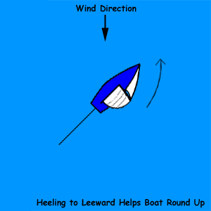

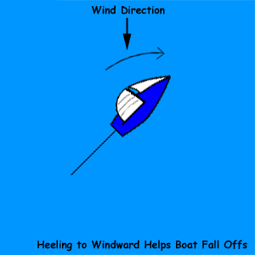

Fore and aft trim also affect the way a boat sails without a rudder. If you put a lot of weight in the stern, it moves the center of effort of the sails aft and the center of effort of the blades in the water forward. The boat will then round up. If you move your weight to the bow so that the stern is way up in the air, the boat will fall off. In fact, the Optimist has such a large rudder that it can't be sailed with only heeling angles: one has to go and sit at the mast with the bow low in the water and the stern way out to get the boat to sail a straight course.
Here's a chart to help you figure out how to sail your boat without a rudder.
 | Head Up | Fall Off
Sails | Jib out, main in | Jib in, main out
Boat Heel | Heel to leeward | Heel to weather
Boat Fore/Aft Trim | Weight aft | Weight forward

