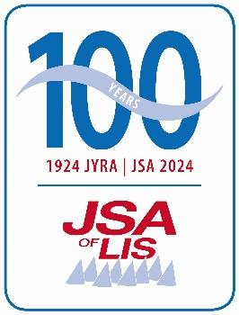
Cut and paste club burgee here
Regatta Name
Yacht Club Name
Yacht Club Address

Regatta Date

Sailing Instructions

- Yacht Club Name is the Organizing Authority (OA) in partnership with the Junior Sailing Association of Long Island Sound.
- The notation ‘[DP]’ in a rule means that the penalty for a breach of the rule may, at the discretion of the protest committee, be less than disqualification.
- The notation ‘[NP]’ in a rule of the sailing instructions (SIs) means that a boat may not protest another boat for breaking that rule. This changes RRS 60.1.

Abbreviations:
PC - Protest Committee RC - Race Committee
OA - Organizing Authority SI - Sailing Instructions
RRS - Racing Rules of Sailing JSA - Junior Sailing Association of LIS
NOR - Notice of Race

1 RULES
1.1 The regatta is governed by:
a. the rules as defined in The Racing Rules of Saling
b. C420, ILCA and RS Feva Class Rules. While the JSA accepts the use of both “ILCA” and “Laser Performance” boats, as well as practice sails and equipment for such boats, such acceptance is limited to JSA-sponsored events only. (see https://jsalis.org/laser-class for further details.)
c. the Rules for JSA Events
d. the JSA Code of Conduct
e. the US Sailing Athlete Safety Handbook
f. RRS Appendix V1 Penalty at the Time of an Incident, and Appendix V2, Penalty Taken After a Race, will apply.
g. RRS Appendix T, Arbitration will apply

1.2 The following RRS are changed:
a. RRS 61.1(a) is added to as follows: “A boat intending to protest about an incident that occurs in the racing area shall notify the Race Committee (RC) finish boat of her intention as soon as possible after finishing, including (if possible) the boat identification number of the boat(s) being protested. The boat shall not consult with instructors, coaches, or support persons, prior to such notification.”
2 CHANGES TO SAILING INSTRUCTIONS
2.1 Any change to the SIs will be posted no fewer than 30 minutes before the Harbor Start on the day the change takes effect.
2.2 Any change in the Harbor Start or First Warning Signal will be posted no later than the end of the protest time limit on the day before the changes take effect.

3 COMMUNICATIONS
3.1 Notices to competitors will be posted on the official notice board located location or link.
3.2 [DP] While racing, from the first warning signal until the end of the last race of the day, except in an emergency, a boat shall not make voice or data transmissions and shall not receive voice or data communication not available to all boats.
3.3 [DP] Each coach and support vessel shall carry a VHF radio capable of communicating on all US channels.
3.4 [DP] All ILCA/Laser coaches and support vessels shall monitor VHF Channel 5. All C420/Feva coaches and support vessels shall monitor VHF Channel 77. Support persons shall maintain silence on these channels unless safety-related communication with the race committee or safety patrol is necessary. Yacht Club Name base can be reached on VHF channel XX for operational and emergency support.
3.5 These Sailing Instructions, the NoR, results and other information will be available at link.

4 CODE OF CONDUCT
4.1 [DP] Competitors and support persons shall comply with reasonable requests from race officials and shall comply with the JSA Code of Conduct (attached below).
5 SIGNALS MADE ASHORE
5.1 Signals made ashore will be displayed from location.
5.2 When flag AP is displayed ashore, ‘1 minute’ is replaced with ‘not less than 45 minutes’ in Race Signals AP.
5.3 [DP] Flag D with one sound means ‘Boats shall not leave the dock until this signal is made. The warning signal will not be made before the scheduled time or less than 45 minutes after flag D is displayed.’

6 SCHEDULE OF RACES
6.1 Six or more races are scheduled.
6.2 The racing schedule is as follows:
Day | Date | Time | Activity | Location
Day | Date | 1800 - 2100 | Early drop off
Day | Date | 0730 - 0900 | Registration
 |  | 0730 - 0900 | Safety Check
 |  | 0730 - 0930 | Breakfast Bar
 |  | 0900 | Instructors Meeting
 |  | 0930 | Competitors Meeting
 |  | 1000 | Harbor Start
 |  | 1100 | First Warning Signal
 |  |  | Lunch | On the Water (BYO)
 |  | 1530 | No Warning Signal after
 |  | Post Racing | Snacks and Awards

7 CLASS FLAGS
7.1 The class flags will be:
Club 420 Numeral One (white pennant with red circle) 
Feva Numeral Two (blue pennant with white circle)` 
Laser Standard Numeral Three (red, white, and blue pennant) 
Laser Radial Numeral Four (red pennant with white cross) 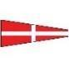
Laser 4.7 Numeral Five (yellow and blue pennant) 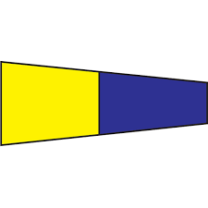

8 RACING AREA
8.1 The racing area will be location and chart excerpt if possible.

9 THE COURSES
9.1 The courses shall be W1, W2, T or TW as shown in “Diagram A: Courses,” attached below
9.2 The course to be sailed will be displayed from the RC signal boat before or with the warning signal for each class.
9.4 If one of the gate marks is missing, the remaining mark shall be rounded to port.

10 MARKS
10.1 Original marks will be orange inflatable tetrahedrons for the ILCA/Laser course and yellow inflatable tetrahedrons for the 420/Feva course. It should be noted that the color of the marks depicted in any course diagram should not be construed as the color marks to be used.
10.2 New marks as provided for in SI 12, CHANGE OF THE NEXT LEG OF THE COURSE, will be green inflatable tetrahedrons.
10.3 The offset mark, when utilized, shall be an orange inflatable ball.
10.4 The starting line will be between an orange flag displayed by a race committee signal boat at the starboard end, and an orange flag displayed on a race committee pin boat anchored at the port end.
OR
10.4 The starting line is between a staff displaying an orange flag on the signal vessel at the starboard end, and the course side of the port-end starting mark.
10.5 The finishing line is between a blue flag displayed by a race committee signal boat at the port end, and the course side of the starboard-end finishing mark.
- THE START
  - Races will be started using Appendix U, “Audible-Signal Racing System”, with the following additions and changes:
- The class flag(s) of the class(es) to start will be hoisted before the warning signal and will be dropped at the start.
- A series of short horn blasts and hoisting of class flag(s) indicates a warning signal is forthcoming and competitors for the indicated division(s) should proceed immediately to the starting area.
c) If RRS 30.1 (the “I flag rule”), RRS 30.2 (the “Z flag rule”), RRS 30.3 (the “U flag rule”), or RRS 30.4 (the “black flag rule”) is in effect, the appropriate flag(s) will be displayed with the warning signal and will be dropped one minute before the start.
d) If either RRS 29.1 (Individual Recall) or RRS 29.2 (General Recall) is in effect, the appropriate flag will be displayed with its corresponding sound signal.
e) This changes Appendix U1 and RRS 26.
OR
11.1 Races will be started using RRS 26.
11.2 A boat that does not start within four minutes after her starting signal will be scored Did Not Start without a hearing. This changes RRS A5.
11.3 The starting line is between an orange flag displayed by a race committee signal boat on the starboard end, and an orange flag displayed on a race committee pin boat anchored at the port end.
OR
11.3 The starting line is between a staff displaying an orange flag on the signal vessel at the starboard end and the course side of the port-end starting mark.
11.4 [DP] Boats shall remain to leeward of the starting area when not racing or preparing to start.
11.5 On the C420/Feva course, the C420s will start first, followed by the RS Fevas. On the ILCA/Laser course, ILCA 6/Radials will start first, followed by the ILCA 4s, then the ILCA 7/Standards.
11.6 If any part of a boat’s hull is on the course side of the starting line at her starting signal and she is identified, the race committee will attempt to hail her sail number. A boat may not request redress based on failure of the race committee to hail her number, failure of her to hear such a hail, or the order in which boats are hailed. This changes RRS 61.1(a).

12 CHANGE OF THE NEXT LEG OF THE COURSE
12.1 To change the next leg of the course, the race committee will lay a new mark (or move the finishing line) and remove the original mark as soon as practicable. When in a subsequent change a new mark is replaced, it will be replaced by an original mark.
12.2 If the weather mark is changed, no offset mark shall be used.

13 THE FINISH
13.1 The finishing line is between a blue flag displayed by a race committee signal boat on its starboard side and the course side of a finishing mark.
13.2 Flag A displayed while boats are finishing means ‘No more racing today’.

14 TIME LIMITS
14.1 The Race Time Limit (see RRS 35), and the Finishing Window are shown below.
Class Race Time Limit Finishing Window
All Classes 60 Minutes 20 Minutes

14.2 The Finishing Window is the time for boats to finish after the first boat sails the course. Boats starting but failing to sail the course within the Finishing Window, and not subsequently retiring, penalized or given redress, will be scored Time Limit Expired (TLE) without a hearing. A boat scored TLE shall be scored points for the finishing place one more than the finishing place of the last boat that sailed the course within the Finishing Window and was not penalised under RRS 30.3 or 30.4. This changes RRS 35, A5.1, A5.2 and A10.

15 HEARING REQUESTS
15.1 Protest and scoring inquiry forms are available location.
15.2 if a competitor believes their posted score is incorrect, they may file a scoring inquiry and/or request redress. The RC will post responses to scoring inquiries on the official notice board.
15.3 The protest time limit is 30 minutes after the RC signal boat docks, which shall be posted promptly on the official notice board.
15.4 Notices will be posted no later than 30 minutes after the protest time limit to inform competitors of hearings in which they are parties or named as witnesses. Hearings will be held in the protest room, located at location.

16 SCORING
16.1 When fewer than six (6) races have been completed, a boat’s series score will be the total of her race scores. When six (6) to ten (10) races have been completed, a boat’s series score will be the total of her race scores excluding her worst score. When eleven (11) or more races have been completed, a boat’s series score will be the total of her race scores excluding her two worst scores.
16.2 One race is required to be scored to constitute a series.
16.3 Divisions that start together will be scored overall.

17 SAFETY REGULATIONS
17.1 [DP] [NP] Before the first warning signal for each day, all boats shall check in by sailing on starboard tack or towing past the stern of the anchored RC signal boat and hailing their sail number until acknowledged by a committee member.
17.2 Each competitor and instructor/coach shall wear a US Coast Guard approved personal flotation device while on the water in accordance with JSA Rule 2.1.
17.3 [DP] If a boat retires from a race or for the day, the sailor shall notify an RC boat before leaving the race area or have their coach notify the RC on the VHF channel specified for their course. If this is not possible, the sailor (or their coach) shall notify a staff member immediately after arriving ashore.
18 EQUIPMENT AND MEASUREMENT CHECKS
18.1 [NP] A boat or equipment may be inspected at any time for compliance with Class and JSA rules.
18.2 When instructed by a race official on the water, a boat shall proceed to a designated area for inspection.
19 REPLACEMENT OF CREW OR EQUIPMENT
19.1 [DP] Substitution of competitors is not allowed without prior written approval of the RC.
19.2 [DP] Substitution of damaged or lost equipment is not allowed unless authorized in writing by the RC. Requests for substitution shall be made to the committee at the first reasonable opportunity, which may be after the race.
20 [DP] [NP] SUPPORT TEAMS
20.1 Instructors, coaches, and spectators shall stay to leeward of the starting area or at least 50 yards outside the racing area. Coaching is not permitted after a general recall.
20.2 Support teams, including all support persons and support person vessels, shall comply with the JSA Support Team Regulations attached to this document.

21 [NP] [DP] TRASH DISPOSAL
21.1 Competitors and support persons shall not intentionally put trash in the water. This rule applies at all times while afloat. Trash may be placed aboard support or RC boats.
22 PRIZES

22.1 Prizes will be awarded to the top five finishers in the ILCA 6/ Radial, C420 and RS Feva Divisions, top three in the ILCA 4.7, Top two in ILCA 7/Standard. Equal prizes will be awarded to helm and crew positions.

22.2 A sportsmanship trophy may be awarded at the discretion of the RC.
23 [NP] [DP] DRONE USAGE
23.1 Drones are not allowed at the event unless they are authorized by the Organizing Authority (OA). Content from OA authorized drones should not be used for coaching during the event. If the content is used for coaching (or other similar purposes) it shall be made available to all competitors at the same time and not during competition hours. Further, the content shall be made available to the JSA for promotional purposes by promptly emailing said content to news@jsalis.org."

24 RISK STATEMENT
24.1 RRS 3 states: ‘The responsibility for a boat’s decision to participate in a race or to continue to race is hers alone.’ By participating in this event each competitor agrees and acknowledges that sailing is a potentially dangerous activity with inherent risks. These risks include strong winds and rough seas, sudden changes in weather, failure of equipment, boat handling errors, poor seamanship by other boats, loss of balance on an unstable platform and fatigue resulting in increased risk of injury. Inherent in the sport of sailing is the risk of permanent, catastrophic injury or death by drowning, trauma, hypothermia or other causes.

I agree to be bound by all rules that govern this event.

Regatta Chairmen: Name
Principal Race Officer: Name
Chief Judge Name

Questions: email

Yacht Club Name
Address
Address
Phone: Number
VHF Channel XX

Diagram A – Courses

Course W1 Course W2
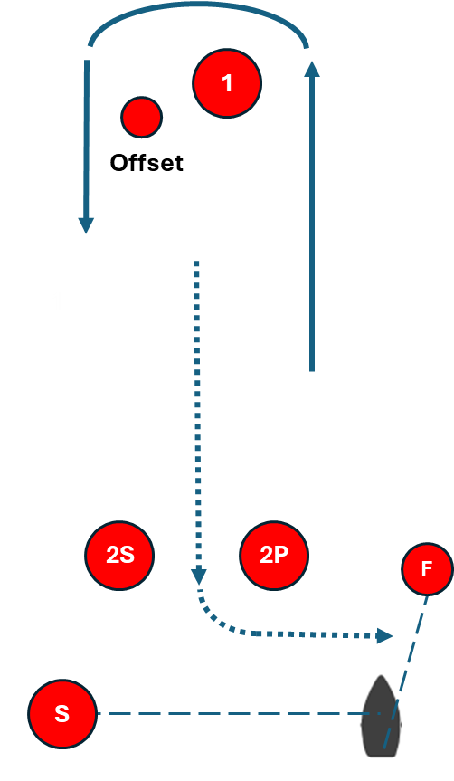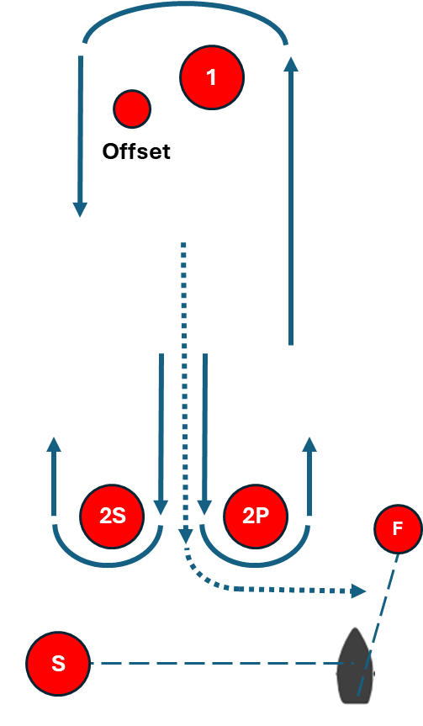
Marks: 1, Offset, 2P, Finish Marks: 1, Offset, 2P or 2S, 1, Offset, 2P, Finish

Course T Course TW
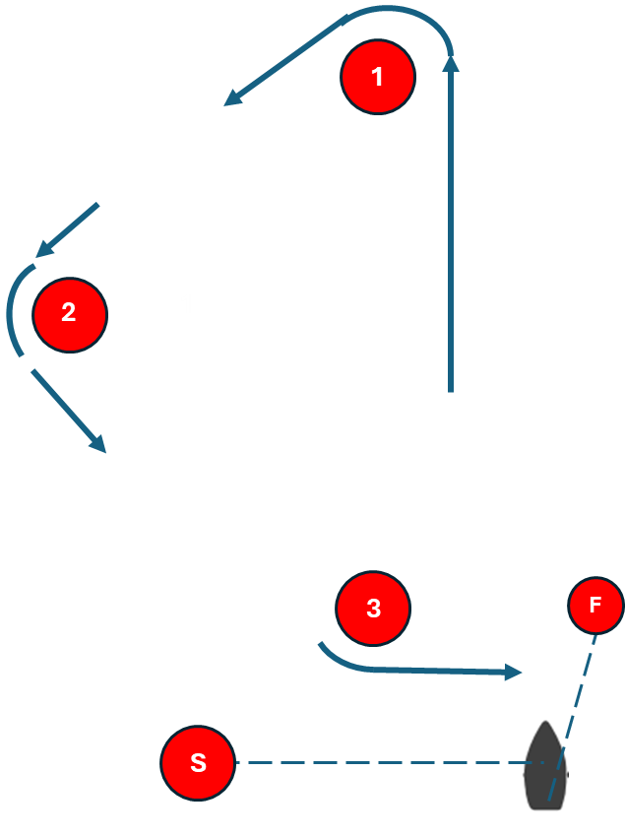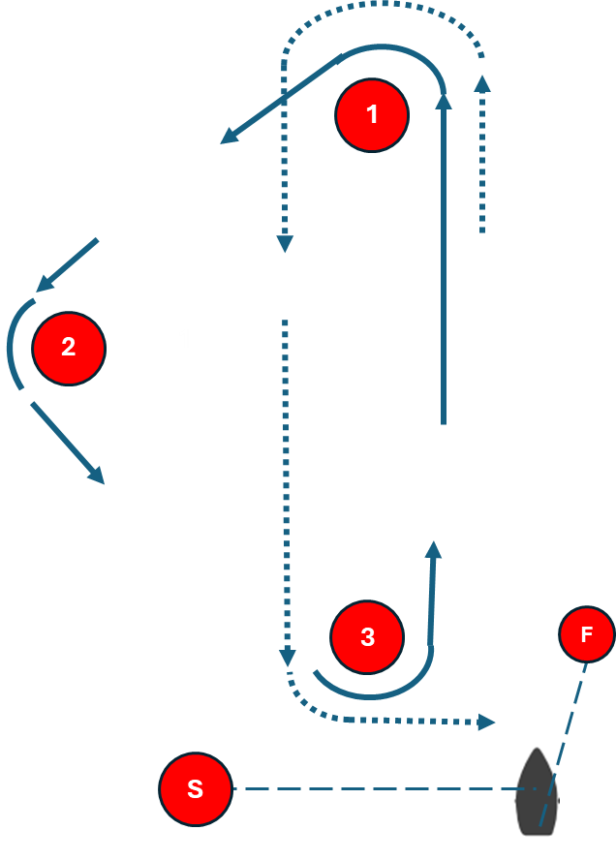

Marks: 1, 2, 3, Finish Marks: 1, 2, 3, 1, 3, Finish

Junior Sailing Association of Long Island Sound
Code of Conduct
2025

Introduction
The JSA Code of Conduct applies to all JSA Sailors, Parents, Coaches and anyone present in support of a sailor or an event (“Support Person”) when attending JSA Sanctioned Events. It applies from the time one arrives at the event to the time of departure, and it applies to conduct both on and off the water. The Code is intended to prescribe appropriate behavior for every aspect of participation in a JSA event. It is not intended to establish a set of rules.
Commitment
I promise:
- I will use my best efforts to learn and follow the Racing Rules of Sailing.
- I will be honest, fair, courteous, respectful and a good sport, whether I am winning or losing.
- I will treat competitors, coaches, regatta officials, parents, hosts and all others with respect, even if I believe that person is wrong.
- I will comply with the reasonable requests of any regatta official, team coach and/or parent chaperone that may be associated with an event.
- I will respect the rules and conditions of the regatta, the Host Club or sailing venue.
- I will follow all regulations governing the operation of support craft.
- I will not use another's property without permission, steal or damage another's property.
- I will not hit, abuse, bully, make fun of or call anyone names.
- I will not swear or curse.
- I will not abuse my equipment in anger.
- I will follow all safety procedures and instructions given by race officials, regatta hosts and other responsible adults. I will promptly notify a race official, coach or responsible adult if another person is in danger.
- I will not engage in any conduct that endangers the health or safety of another competitor.
- I will not use alcohol, tobacco, or any drugs that were not prescribed specifically for me.
- I will respect the grounds of the sailing venue and the waters on which I sail, by being responsible for my items and disposing of my trash responsibly.
- I will demonstrate “Corinthian Spirit”, meaning I will place good sportsmanship, fair play and respect for the rules above winning.
Enforcement of the Code
It is expected that a Sailor and his/her support group enters an Event understanding the Code. First and foremost, compliance with this Code is mandatory and, if words or actions result in a breach of the Code, the expectation is that the Sailor will report him or herself to the Organizing Authority. Alternatively, a breach of the Code may be reported by peers or others in attendance who have witnessed such an incident.
Handling of Code Violations
When necessary, enforcement may take the form of disciplinary action as outlined by the RRS, the US Sailing SafeSport Handbook, and the US Sailing Regulations and Bylaws.
If an incident is brought to the attention of the Organizing Authority, Event Host and/or the Protest Committee alleging that a competitor has violated this Code, the Protest Committee shall notify the competitor and conduct a hearing that meets the requirements of Part 5, Section B of the RRS. Under such circumstances, the competitor has the right to voluntarily withdraw from the event rather than proceeding with a hearing.
If the Protest Committee decides that the competitor has violated the Code and is not exonerated, it may:
- remove some or all of the competitor’s event privileges or benefits,
- disqualify the competitor’s boat from the race or races sailed nearest in time to that of the incident, or
- disqualify the competitor’s boat from all races in the event and exclude the competitor from the event or venue.
Further action may be determined by the Protest Committee if warranted including considering calling a hearing under RRS 69.2(b) or remanding it to the US Sailing Review Board or SafeSport.
Under such circumstances, the Host Club Event Chair shall take disciplinary action within 48 hours and shall notify the Chair of the JSA regarding the action.
Scoring
When a competitor withdraws from part of an event pursuant to the Code, the scores of all completed races shall stand for the purposes of determining the seeding of subsequent rounds or stages in the event. However, that competitor’s boat/team will no longer be eligible to compete in the event, shall be removed from the final event scores, and each boat/team with a worse finishing place in the event shall be moved up one place. The same scoring applies if a boat is disqualified from the remaining races in an event.
Parents, Coaches & Support Persons
Parents, Coaches and Support Persons are expected to adhere to the Code and the Commitments listed above. It is expected that any violation of the Code and/or Commitments will be reported to the Organizing Authority, Event Host and/or Protest Committee and will be addressed as outlined under “Handling of Code Violations” above.
The actions that a Protest Committee may carry out for Support Person misconduct are defined in RRS 64.4. They include:
- issue a warning;
- exclude the person from the event or venue or remove any privileges or benefits, or
- take any other action within its jurisdiction as provided by the rules.
The protest committee may also penalize a competitor for the breach of a rule by a support person by changing the boat’s score in a single race, up to and including DSQ, when the protest committee decides that:
- the competitor may have gained a competitive advantage as the result of the breach by the support person, or
- that the Parent, Coach or Support Person has committed a further breach after the competitor has been warned by the protest committee that a penalty may be imposed.
JSA Support Team Regulations

In addition to the procedures specified in the SUPPORT TEAMS section of the Sailing Instructions, the JSA requires support persons who communicate with race officials by VHF radio to use these protocols:
- Hail the RC and identify yourself by using your Name, your Club/Organization, and your Role (coach, parent, etc.)
- Say your message.
- Receive response
- Acknowledge the response
- Do not argue with the RC if you disagree with its response.
- End the communication by thanking the RC volunteers for their service.

Communications that do not include a support person’s identity, or are argumentative and abusive, may be subject to penalties as described in the JSA Code of Conduct.

Support Persons are reminded:
a.) RRS 4.1(b) states: “A support person by providing support, or a parent or guardian by permitting their child to enter an event agrees to accept the rules.”
b.) RRS 4.2 states, “Each competitor and boat owner agrees, on behalf of their support persons, that such support persons are bound by the rules.”
c.) RRS 60.3 states: The Protest Committee may call a hearing, if any support person has broken a rule.
d.) RRS 64.5 Decisions Concerning Support Persons may include a warning, exclusion from the event venue or worse, and may include penalties against their sailors.

