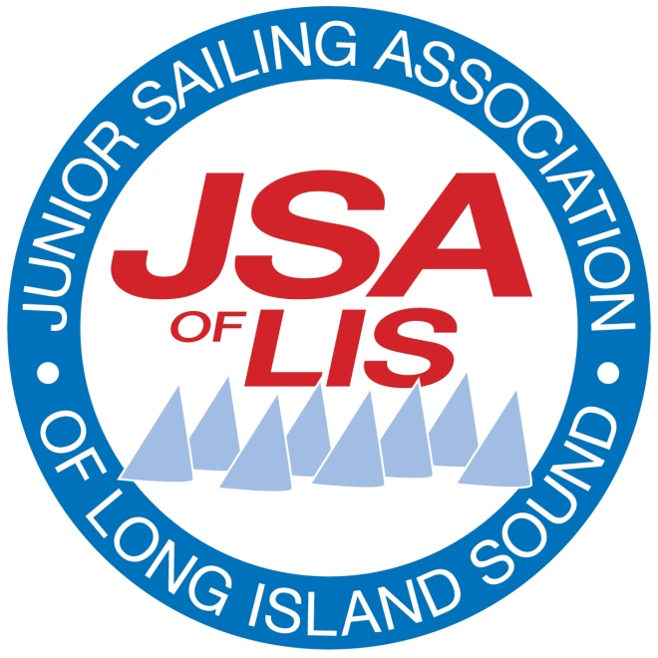

JSA of LIS
Intent to Bid for 2019 Championship Event Hosting

Thank you for your interest in hosting a JSA Championship. The JSA partners with Member Clubs (Event Hosts) that are selected to host JSA events. Event Hosts are responsible for all elements of on-and off-water Event Management to provide a memorable event for both sailors and volunteers. The role of the JSA in Event Management is to ensure consistency and adherence to JSA Rules and best practices for the benefit of our sailors.

The selection of Event Hosts is based on a set of criteria including, but not limited to:
- The physical and organizational resources required for the vastly different boat classes
- Prior year hosting locations
- Prior year champions’ home clubs
The JSA has assembled a wealth of information in the Regatta Management section of our website: http://jsalis.org/regatta-management. There you can find guidelines and best practices for planning and managing a JSA event, as well as a recommended planning timetable. To best determine your ability to host a JSA event, please review these guidelines before responding:
- Rules for JSA Events
- Race Course Options
Championship Event | Target Dates
Optimist | TBD
420 / Laser / Laser Radial | TBD
Pixel | TBD
Feva | TBD
- JSA Regatta Playbook
Target Dates for 2019 Championship Events

Notes:
- Pixel events typically include one day of racing. Other events include two days of racing.
- Member Clubs will assist the JSA with finding qualified judges.
- A JSA representative attends the championship as the Partner Organizing Authority.

Please indicate your interest in hosting a JSA Championship Event. JSALIS understands that resources of JSA Member Clubs varies greatly, and will vette all applicants to match boat classes with appropriate venues. We also encourage interested first-timers to apply. The success of any regatta is contained in organization and details, and the JSA is available to provide guidance to inexperienced clubs for first time hosting.

JSA of LIS Championship Event Hosting Intent to Bid (continued)

Event Hosts are selected in late Fall. Successful bidders are required to follow up within one month with the JSA of LIS Championship Event Host Application providing the detailed plan for all aspects of the event. By submitting this Intent to Bid Form, bidders are committing to their ability to submit the application within the one month deadline.

Event (circle one): Optimist 420/Laser/Laser Radial Pixel Feva

Proposed Dates:

Proposing Club:

Contact Person:

Phone: Email:

Briefly describe why your Club would like to host this event:

Event guidelines are available at jsalis.org > Regatta Management Resources.
Email your completed form to info@jsalis.org.

Thank you for your interest in hosting a JSALIS Championship event!

Applicant Signature: Date:

- I have reviewed the Event Guidelines listed above and we agree to the Organizing Authority Partnership with the JSA.

JSA & Event Host Club
Organizing Authority Partnership

The JSA cooperates in the partnership with each Member Club (the “Host”) that is selected to host a JSA Championship event. The role of the JSA is to ensure consistency and adherence to JSA Rules and best practices for the benefit of our sailors and Hosts, while empowering the Host to provide a memorable event on- and off-water for sailors and volunteers.

The planning process is critical to a successful event, and the JSA is a resource for information that will contribute to the ability of the Host to manage a successful event. The JSA has assembled a wealth of information in the Regatta Management section of our website http://jsalis.org/regatta-management. It contains guidelines and best practices for planning and managing a JSA event, as well as a recommended planning timetable. Here are some key resources:
• Organizing Authority Partnership
• JSA Regatta Playbook
• Rules for JSA Events
• Templates for NOR and SI, with Race Course diagrams

Host’s Role (see the monthly planning schedule in the JSA Regatta Playbook for details):
- Identify the Event Chair, the PRO and the Scorer for the event. Provide JSA with information about the experience of these key persons. Confirm that:
  - The PRO does not have a sailor on the course they are managing.
  - The Scorer has experience using Regatta Toolbox or will attend training at the Event Management Workshop.
- Adhere to the JSA Race Course Templates located on the JSA website in the Event Management section.
- Follow the templates published by the JSA to draft the Notice of Race and Sailing Instructions. Submit NOR and SI draft to JSA for approval by May 15 and final by May 30. [see the templates on JSA website at http://jsalis.org/regatta-management]
- Provide the signal, judge, safety and support boats. (Note: JSA utilizes on-water judging to enforce Rule 42.)
- Utilize the JSA’s Regatta Toolbox for scoring.
- Include a JSA Representative in its regular planning meetings, and in status updates, so that communications flow smoothly for both the on- and off-water elements throughout the planning process.
- Send the Event Chair, and if possible the PRO and the Scorer, to the JSA Event Management Workshop in April.
- Provide a place aboard the signal boat or the judge boat for a JSA on-water representative. [so they may confer with the PRO and/or Chief Judge during racing]
- Prepare a budget for the event that will enable the entry fee to be approved by the JSA. [target fee suggested is $60/sailor for each event day. Instructors are not to be charged an entry fee. Specify what items and services are provided for payment of the entry fee.]
- Solicit sponsorship from local businesses.
- Ensure the Host has sufficient insurance to cover the event.
- Provide housing for the competitors who will travel more than 45 minute drive (or across the Throgs Neck Bridge), and housing for the JSA representative, PRO and race officials (if from outside the region).
- Arrange for the event to adhere to the guidelines of the Clean Regatta Program promoted by Sailors for the Sea.
- Provide written report at end of the event summarizing activity and results. (also daily for a multi-day event).

JSA’s Role:
- Ensure that the regattas are being run under JSA approved conditions with JSA race formats.
- Provide a range of suitable dates for the event, and approve the dates proposed by the Host.
- Approve the Notice of Race and Sailing Instructions with Race Course diagrams.
- Publicize the NOR, SIs, other materials, and Results on the JSA website and calendar.
- Provide a representative during the planning stage and on-the-water to ensure adherence to JSA rules and best practices during the event.
- Select judges and ensure the PRO has the appropriate qualifications [with assistance of the Host].
- Approve the event entry fee that is proposed by the Host.
- Ensure the appropriate usage of JSA, sponsor and other logos. Provides loaner championship banners and other JSA promotional identity items
- Provide funding for the championship keeper trophies, delivers the perpetual trophies for display during the event, and engraves winners’ names on the perpetuals afterwards.
- Manage the regional communication and public relations including but not limited to Facebook, Twitter, and other social media [using content provided by the Host].

