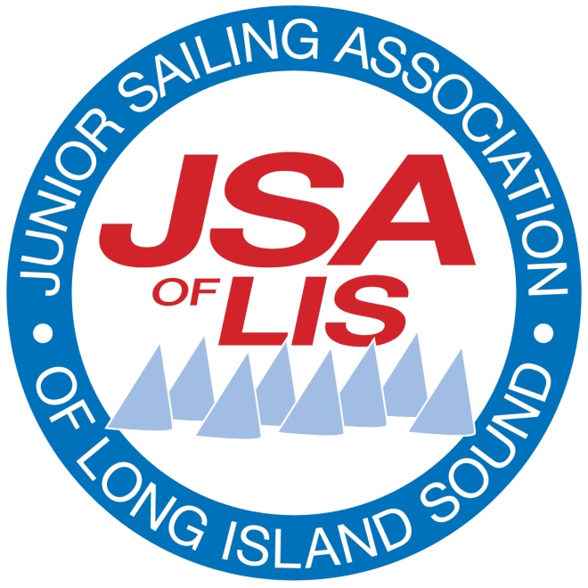

JSA of LIS Championship Event Hosting
Intent to Bid

Thank you for your interest in hosting a JSA Championship. The JSA depends on the support of its Member Clubs for our continued success in providing excellent regatta experiences in a tightly packed summer regatta schedule. The JSA cooperates in partnership with each Member Club (the “Host”) that is selected to host a JSA Championship event. Hosts are responsible for all elements of on-and off-water Event Management to provide a memorable event for both sailors and volunteers. The role of the JSA in Event Management is to ensure consistency and adherence to JSA Rules and best practices for the benefit of our sailors and the Host.

The selection of Hosts by the JSA is based on a set of criteria including, but not limited to:
- The Host’s physical capacity and organizational resources
- Demonstrated ability to run a major regatta
- Varying the venues
- The home clubs of prior year champions

The JSA has assembled a wealth of information in the Regatta Management section of our website: http://jsalis.org/regatta-management. There you can find guidelines and best practices for planning and managing a JSA event, as well as a recommended planning timetable. To best determine your ability to host a JSA event, please review these guidelines before responding:
- JSA & Event Host Club Organizing Authority Partnership
- JSA Regatta Playbook
- Rules for JSA Events
- Templates for NOR and SI, with Race Course diagrams
2018 Target Dates for Championship Events
Championship Event | Target Dates | Note
Optimist | TBD | 2 days
420 / Laser / Laser Radial | TBD | 2 days
Pixel | TBD | 1 day
Feva | TBD | 1 day

Please indicate the event your club is interested in hosting. JSA understands that resources of JSA Member Clubs vary greatly, and will review all applicants to match boat classes with appropriate venues. We also encourage interested first-timers to apply. The success of any regatta is contained in organization and details, and the JSA is available to provide guidance to inexperienced clubs for first time hosting.

Event Hosts are selected in late Fall. Successful bidders will be required to follow up within one month with the JSA of LIS Championship Event Host Application providing the detailed plan for all aspects of the event. By submitting this Intent to Bid Form, bidders are committing to their ability to submit the application within the one month deadline.

Proposed Event
Proposed Dates:
Proposing Club:
Contact Person:
Phone: Email:
State why your Club would like to host this event and briefly describe the Club’s regatta hosting abilities:

Event guidelines are available at http://jsalis.org/regatta-management. Email your completed form to regatta@jsalis.org. Thank you for your interest in hosting a JSA Championship event!

Event Chair and Race Committee Chair Signature: Date:

- I have reviewed the Event Guidelines listed above and my club agrees to the Organizing Authority Partnership with the JSA.

Attachment: JSA Organizing Authority Partnership

JSA & Event Host Club
Organizing Authority Partnership

The JSA cooperates in the partnership with each Member Club (the “Host”) that is selected to host a JSA Championship event. The role of the JSA is to ensure consistency and adherence to JSA Rules and best practices for the benefit of our sailors and Hosts, while empowering the Host to provide a memorable event on- and off-water for sailors and volunteers.

The planning process is critical to a successful event, and the JSA is a resource for information that will contribute to ability of the Host to manage a successful event. The JSA has assembled a wealth of information in the Regatta Management section of our website http://jsalis.org/regatta-management. It contains guidelines and best practices for planning and managing a JSA event, as well as a recommended planning timetable. Here are some key resources:
• Organizing Authority Partnership
• JSA Regatta Playbook
• Rules for JSA Events
• Templates for NOR and SI, with Race Course diagrams

Host’s Role:
- Identify the Event Chair, the PRO and the Scorer for the event. Provide JSA with information about the experience of these key persons.
- Follow the monthly planning schedule in the JSA Regatta Playbook
- Include a JSA Representative in its regular planning meetings, and in status updates, so that communications flow smoothly for both the on- and off-water elements throughout the planning process.
- Send the Event Chair, and if possible the PRO and the Scorer, to the JSA Event Management Workshop in April.
- Follow the templates published by the JSA to draft the Notice of Race and Sailing Instructions with Race Course diagrams. Submit NOR and SI draft to JSA for approval by May 15 and final by May 30. [see the templates on JSA website at http://jsalis.org/regatta-management]
- Invite a JSA representative to a demonstration by the Scorer that will confirm the scoring procedure is able to accurately and quickly score by overall position, even if a large fleet is started in multiple round-robin divisions.
- Provide the signal, judge, safety and support boats.

- Provide a place aboard the signal boat or the judge boat for a JSA on-water representative. [so they may confer with the PRO and/or Chief Judge during racing]
- Prepare a budget for the event that will enable the entry fee to be approved by the JSA. [target fee suggested is $60/sailor for each event day. Instructors are not to be charged an entry fee. Specify what items and services are provided for payment of the entry fee.]
- Solicit sponsorship from local businesses.
- Ensure sufficient insurance to cover the event.
- Provide housing for the competitors who will travel more than 45 minute drive (or across the Throgs Neck Bridge), and housing for the JSA representative, PRO and race officials (if from outside the region).
- Arrange for the event to adhere to the guidelines of the Clean Regatta Program promoted by Sailors for the Sea.
- Provide written report at end of the event summarizing activity and results. (also daily for a multi-day event).

JSA’s Role:
- Ensure that the regattas are being run under JSA approved conditions with JSA race formats.
- Provide a range of suitable dates for the event, and approves the dates proposed by the Host.
- Approve the Notice of Race and Sailing Instructions with Race Course diagrams.
- Publicize the NOR, SIs, other materials, and Results on the JSA website and calendar.
- Provide a representative during the planning stage and on-the-water to ensure adherence to JSA rules and best practices during the event.
- Select judges and ensure the PRO has the appropriate qualifications [with assistance of the Host].
- Approve the event entry fee that is proposed by the Host.
- Ensure the appropriate usage of JSA, sponsor and other logos. Provides loaner championship banners and other JSA promotional identity items
- Provide funding for the championship keeper trophies, delivers the perpetual trophies for display during the event, and engraves winners’ names on the perpetuals afterwards.
- Manage the regional communication and public relations including but not limited to Facebook, Twitter, and other social media [using content provided by the Host].

