Lesson 08 - Docking Techniques
Since dock layouts and wind and water conditions vary greatly, it's impossible to write up detailed instructions on how to land a boat on a dock. However, here are a few tips to help improve your prowess at landing a boat on a dock safely and efficiently.
First, plan your landing so that you will be facing the wind, waves, or current (whichever happens to be the strongest force) when you tie up. In general, the wind and waves will move in the same direction. If it's windy and there's little current, plan to land your boat so that the bow points towards the wind and waves. If there's little wind and current is a more important factor, land and tie your boat up so that it faces the current.
Many docks have some rubber around the edges, but this sort of protection for your boat is a last resort at best. Always use fenders to keep your boat from rubbing against the dock and getting scratched up.
Most people know that a boat should be tied up with a bow line and a stern line. What they don't realize is the importance of spring lines. Spring lines are lines that run diagonally from the boat to the dock to keep the boat from moving forwards or backwards. A forward spring line runs from the bow to the dock (near the boat's transom) and helps keep the boat from moving forward. An aft spring line runs from the stern to the dock (near the boat's bow) and helps keep the boat from moving backwards. Most of the time, the spring lines can be attached to strong gear on the side of the boat, such as a toe rail (be sure that the line won't chafe through on sharp edges), cleats mounted in the middle of the boat by the toe rail, the base of shrouds (bottom of the turnbuckles), or winches on the side of the cockpit. As mentioned above, plan for and look out for chafe if the boat will be at the dock longer than a few minutes - dock lines have a way of chafing and breaking.
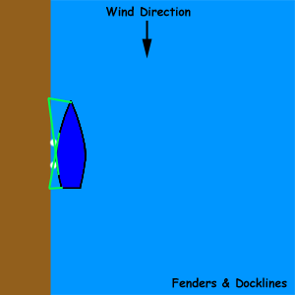

It's always a good idea to tie up on the leeward side of a dock, especially if you'll be tied up for a while. This will use the dock as a buffer to reduce the wave action, and reduce the boat and dock pounding into each other.
Don't forget the tide! If you're tying up to a fixed wall like a seawall or a dock that doesn't rise and fall with the height of the water, you'll have to remember to leave enough slack in your lines for the boat to fall as the tide goes out. Many unfortunate souls have tied their boat to a pier at high tide and not left enough slack in the line. When they returned to the boat, the cleats and deck gear had been ripped out from the strain of the boat pulling against the tight dock lines as the boat sank lower as the tide ebbed.
If you'll be tied to a dock for a long time, relying on fenders only to protect the boat won't be enough. It's best if you can keep your boat from touching anything completely. Small motorboats use fiberglass poles to hold their boats away from the dock. One technique that works for sailors is to run an anchor out to the channel, and winching out the anchor line slack from the primary winches. As the anchor line gets tighter and tighter, it will pull the boat away from the dock. We used this technique when tied to a stone pier in Bermuda when a small storm was predicted, and there were no places to safely anchor the boat in the harbor during the storm.

