Lesson 07 - MOB - Man Overboard
Many people have been lost overboard and successfully rescued, but there have been several people lost overboard who have never been recovered, or who had drowned by the time that they were recovered. Losing someone overboard can be one of the most dangerous and terrifying experiences that sailors will ever confront. Below are some ideas and techniques that should help increase the chances of a successful recovery. It has been said that an ounce of prevention is worth a pound of cure. The best way to successfully recover a Man Overboard (MOB) is to never have the person become separated from the boat in the first place. A few safety precautions will help assure a successful recovery.
The first thing is to learn how to perform a MOB recovery, and then practice the recovery techniques.
When sailing in rough weather or offshore or by yourself, consider rigging jacklines and having the crew wear harnesses. If someone was to fall overboard, the worst that would happen is that they would be dragged alongside the boat and get wet. The harness should be attached to the jacklines by tethers with quick-release fittings on the harness side of the tether. If one was dragged underwater, they could release the tether so they could pop to the surface.
When purchasing a harness, consider a harness with an inflatable lifejacket built into it. The best type inflates automatically when submerged in water - even if knocked unconscious, the lifejacket will still inflate. A manual inflation type is also available, which only inflates when a trigger mechanism is pulled. Wearing a life jacket will greatly increase the chances of recovering a MOB successfully.
There is safety gear that you can carry with you to help with rescue if you fall overboard. It is remarkably difficult to see a MOB, especially in low-light or high-seas conditions. First, wear bright clothing. Dark blue foul weather gear may look cool, but it will be easier for others to spot you if you if you're wearing an ugly neon green jacket with reflective patches on it. A whistle will allow you to better alert others that you're in trouble, and a strobe light is essential for helping the boat find you at night. Mini-flares and smoke flares can also be carried to help you show the boat your position.
And now for some MOB recovery techniques.
When someone falls in, the person who sees the victim first (the spotter) shouts "Man overboard!" and points at the victim. Until the victim is rescued, the spotter never takes their eyes off the MOB or stops pointing. If there is anything that floats handy, someone should immediately throw it into the water to provide additional flotation if the victim needs it. Many boats have a MOM (Man Overboard Module) canister on the transom; if you pull the pin, flotation gear and a marker will be released into the water for the victim. If the boat has a Man Overboard Pole, throw it in - the higher the marker, the easier it will be to see from the boat. Also, someone should run below and press the MOB button on the GPS - this marks the spot that the victim was lost, and provides information to allow the boat to return to that exact spot.
There are three primary ways to recover a MOB. The first is the Quick-stop, the second is the Figure-8, and the third is to use a LifeSling. If you're dropping the sails and starting the motor for the recovery, make sure that there are no lines overboard that may get caught in the prop - the last thing that you want is a problem with the boat that would prevent the timely recovery of the victim. Also, many suggest that you try to avoid getting too far upwind of the victim, since it's harder to slow down when running with the wind.
The Figure-8, a slightly slower recovery method, is executed by the boat first broad reaching away from an MOB, tacking, and then returning on a reciprocal tack.
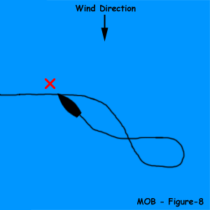

The Quick-stop is performed just like it sounds - stop the boat as quickly as you can. You round the boat up, tack immediately, back the jib, and return to the MOB in a tight circle. It's especially useful when used with a LifeSling.
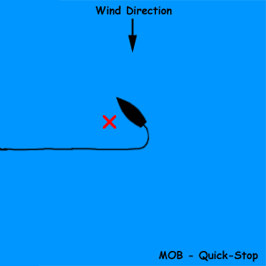

LifeSling are now seen on the stern of almost any boat. They consist of a floating horseshoe attached to the boat with a long piece of floating line. When a person falls overboard, the LifeSling is released into the water. The boat then sails around the MOB in a circle until the sling is dragged next to the victim. The victim places themselves in the LifeSling. The boat drops its sails, drags the victim in on the line, and pulls the victim aboard. If the victim is unable to climb aboard by themselves, the LifeSling can be attached to a halyard, and the victim may be winched aboard.
Hopefully, you will never experience a MOB incident, but if you do, you can be better prepared for a successful recovery of the victim.

