Lesson 09 - Loose and Tight Covers
When you're out ahead, you want to make sure you stay in front. The only way to be completely sure that this happens is to cover your opponent or opponents. There are two types of covers; the "loose" cover and the "tight" cover.
The loose cover is the most common, and is used in fleet, team, and match racing. Your goal is to match the moves of the opponent behind you. If they tack, you tack so that you stay between them and the line. As long as you're between them and the finish, theoretically, it will be impossible for them to pass you. This cover is used to help assure that they don't get some freak windshift or puff and finish ahead of you.
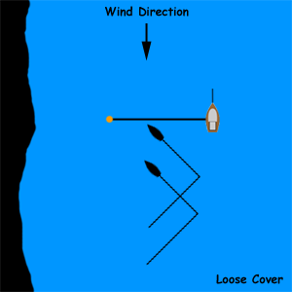

The tight cover is more common in team and match racing. It can also be used in fleet racing, when you're battling for a regatta finish spot with another boat (for example, the two of you are tied for first place in a regatta going into the last race, and the second place boats have a lot more points than the two of you). It involves sitting on your opponent and blowing your bad air all over them to slow them down as much as possible. If they tack, you tack right on top of them. If done right, there's no way that they can pass you. There's something to remember with the tight cover, though - don't forget the big picture. You may be so engrossed with making sure that the boat you're tied with doesn't beat you that the whole fleet finishes the race ahead of you, and other boats are able to finish the regatta ahead of both of you.
