Lesson 07 - Leeward Mark Roundings
Your first step when approaching the leeward mark is to know what your plan is for the next leg. Has the breeze oscillated to the right, so when you get around you'll want to tack to port? Are you heading for the finish, or do you have to go to the windward mark again? Will you have to avoid any boats on starboard still sailing downwind? You need to have a clear idea of what you intend to do when you get around the mark.
As you head towards the leeward mark, try to get an inside overlap so that you'll have buoy-room at the leeward mark. More important than at the weather mark, you will be able to control boats behind you more easily if you're on the inside at the leeward mark rounding.
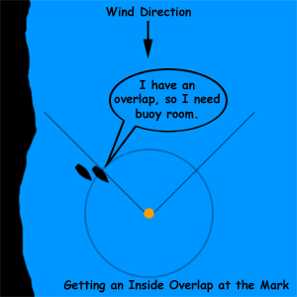

If there are no boats near you, make a tactical round of the leeward mark. A tactical round is when you steer wide of the mark as you go past it, so that when you round up you're going right next to the buoy as you head upwind. If you've got buoy-room on other boats, you're only allowed to make a seamanlike rounding. While this term is vague, you're not allowed to make the nice tactical rounding that you'd make if others weren't around you. The mantra for the tactical rounding is "wide, then close," meaning start your turn far away from the mark so that when you finish the turn and are headed upwind, you'll be right next to the mark and as far upwind as possible.
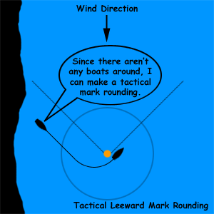

Also, as you round, don't forget to use your weight and sails to turn the boat, rather than using lots of rudder. At the weather mark, you hiked to weather to get the boat to bear off. To round up, let your boat heel to leeward. When you bore off at the weather mark, your jib was tight and the main was loose if you have two sails, or the main was eased if your boat only has one sail. At the leeward mark, crank in the main and take your time bringing the jib in. This will let the wind push the stern of the boat around and help you head up faster.

