Lesson 06 - Downwind Tactics
Downwind tactics are similar to many upwind tactics, but they are reversed. For example, when sailing upwind, you want to sail on the lifted tack because it will get you to the mark faster. However, when sailing downwind, you want to sail on the headed tack because it will get you there faster. So, never sail on the lifted tack downwind; always sail on the headed tack.
If there's a persistent shift, sail away from it first. This is the opposite of upwind persistent shift tactics, when you sail towards the shift.
If the course is skewed and one tack is longer than the other, sail the longer tack first if you can. That way, you'll get upwind of the mark sooner, and will have more options for playing wind shifts as you continue your way downwind to the mark.
It's important to keep an eye on the waves behind you to try to catch and surf down waves. As the stern begins to rise, steer for the lowest spot on the wave ahead of you as you pump your sails. Remember, the rules only allow you one pump per wave, so make it worth the effort! Also, there's a technique to help you surf down waves longer. As you go down a wave, bear off and head towards the low spot of the wave. As the wave passes and your bow begins to dig into the wave in front, head up until you're over the wave. Your boats path should look like a squiggly line as you bear off going down a wave and head up to go over it.
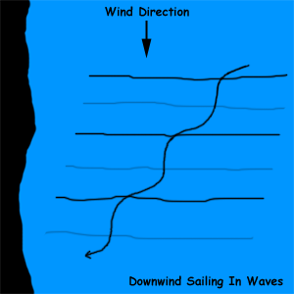

When sailing downwind, you go faster the hotter (closer to the wind) the angle that you sail. For example, I can think of no boat that goes faster dead downwind than on a broad reach or reach. Also, the more wind, the faster the boat goes. So, for your best speed downwind, remember this rule: sail up in the lulls and down in the puffs. When a puff hits you, you'll be going faster. So, bear off and sail a deeper angle towards the mark with your better speed. As the puff passes and you begin to slow down, head up slightly to get your boat's speed up. It will take practice to learn how to sail the fastest downwind because you'll need to learn what angles to sail in what amount of wind.
