Lesson 04 - Upwind Tactics
Are you looking to improve your upwind sailing tactics? Below are several ideas to help you master the upwind legs.
First, you have to know what the wind is doing. Is it oscillating back and forth, or is it in the midst of a persistent shift? This question needs to be answered before you start, because it will help determine your upwind strategy and thus your starting strategy. If you don't know what the wind is doing, try to sail up the middle of the course. However, one side of the course or the other will almost always pay out more than the middle, so try to determine what the wind is doing and thus determine which side of the course you want to sail on.
If the wind is in a persistent shift, you'll want to sail towards the shift after the start to get the most benefit from it. For example, if the breeze is slowly shifting to the right, you'll want to head to the right after the start. Although you'll be slowly headed, when you tack and head back towards the middle, you'll get a persistent lift towards the mark. If instead you continued away from the persistent right shift towards the left side of the course, you may miss the benefits of the big shift or have your position hurt by persistent headers!
Now, if the wind is oscillating back and forth and is not experiencing a persistent shift, you'll want to be sure that you are always sailing on the lifted tack with each shift. If you don't tack on the headers, you'll have to sail more distance to get to the mark than the people who sail on the lifts and tack on the headers. Here's another thought when playing shifts. Although it can be difficult to duck another boat when you have the right of way, it occasionally makes sense. For example, suppose that you're sailing the lifted tack on starboard tack, and a port-tacker, sailing on the headed tack, is on a collision course. You could keep going and shout starboard at the top of your lungs, but you're taking a risk: what if the port-tack boat lee-bows you, and forces you to tack to port to get out of their bad air? You'd be sailing on the headed tack, and they'd be sailing the lifted tack. The best solution in this instance would be to waive the port-tacker ahead and duck them, even though you've got the right-of-way. You may lose a half boatlength of distance from the duck, but they're sailing on the headed tack and you're on the lifted tack - you'll come out ahead in the end.
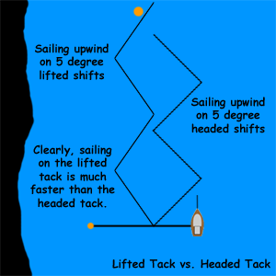

In light air, let your strategy try to maximize the time that you sail in the puffs, and don't try to sail for windshifts (unless they're drastic shifts). The reason for this technique is straightforward: if the breeze is very light, a puff may double the wind's velocity. As the wind speed increases, you should change your strategy from playing the puffs to playing the shifts.
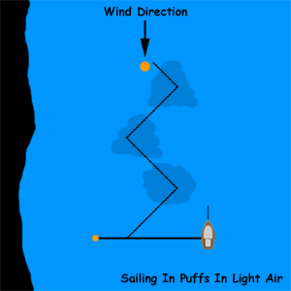

A similar rule of thumb applies to sailing in bad air. Of course, you should avoid sailing in someone's bad air. However, in light air, you are affected much more than you would be in heavy air because the wind pressure that you feel could be cut in half. In heavier air, bad air has less affect on you.
Try not to tack too often. In general, a good roll-tack will cost you 2-3 boatlengths of lost distance as the boat accelerates up to full speed again. A bad tack can cost you 5+ boatlengths of lost distance. While we're on the subject, the rules stipulate that you can't come out of a tack faster than you started it. So, it's illegal for you to keep roll-tacking your boat upwind to keep moving when there's no breeze.

