Lesson 02 - Starting Tactics 1 - Determining Where to Start
Many people agree: it's a lot easier to do well in a race if you get out ahead early, rather than trying to work your way though the fleet to the top. The easiest way to do this is to get a great start. Knowing how to get a great start depends on several factors: being at the favored end, on the line, in clear air and moving quickly, and having the ability to execute your upwind strategy. Generally, you also want to start on starboard tack to have the most rights.
What is the favored end? The favored end of the line is the end that's the farthest upwind and thus closest to the windward mark. If you start at the unfavored end of the line, you'll have to sail extra distance to get to the windward mark. To find the favored end in a dinghy, the fastest and easiest technique is to do a really slow tack from starboard to port tack at the middle of the line when there are no boats around. As your boat goes head-to-wind, try to determine if your bow is pointing more towards one end of the line than the other. The end of the line that your bow points to when you are head-to-wind should be the favored end. The reason that you should perform your wind check from starboard tack instead of port is simple: you still are on "starboard" tack (even if your sail is luffing) as long as your bow doesn't go past head-to-wind.
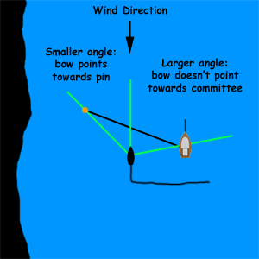

How do you know if you're on the line at the start, especially if you're stuck starting in the middle of the line and aren't close to an end? The best system is to use line sights to gauge your position relative to the line. Before every start, sail around the ends of the starting line and line up the race committee's start line flag with the starting pin, and look for a reference on shore (such as a house, tree, hill, tower, etc.) that's on the same line. When it comes time to start, you can tell if you're below, on, or above the line by looking at the end of the line that's closest to your reference point on land. If you're on the line, your reference point will appear in line with you and the end of the line (such as the house in line with the pin in the image below). If you're below the line, your reference point will appear to be below the end of the line, and you will line up with some other reference point on land (such as the flag in the image below). If you're over the line, the reference point will appear above the end of the line, and you will line up with some other reference point on land (such as the tree in the image below).
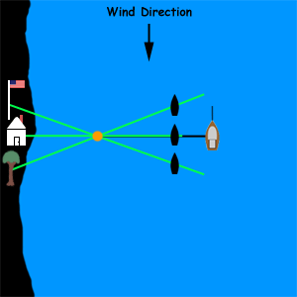

Line sights are essential to starting on the line when starting towards the middle of the line. Many times during the start, there exists "mid-line sag", which is when the boats in the middle are afraid that they'll be over early and hold back, when they are really several boatlengths away from the line. It's called mid-line sag because they start several boatlengths below the line, while boats starting at the ends of the line generally are able to start right on the line. Knowing where the line is helps you start on the line, which helps assure that you'll have clear air after the start so that you can be sailing as fast as possible.
Another important aspect of starts is being able to execute your upwind plan. If you get a great start at the left end of the line but want to immediately tack and go to the right side of the course after the start (perhaps current is better there, or you expect a favorable windshift from there), you may find yourself boxed in by all of the boats still on starboard tack that started on the line - you'll have to wait for them to tack to port and head towards the right side of the course before you can tack, and you won't be able to execute your plan until others give you the opportunity. Consider starting in a different spot if you want to be sure to be able to execute your plan for the upwind leg. For example, if you want to get to the right side of the course right after the start and the left end of the line is heavily favored, consider starting 1/3 of the way from the pin instead of right at the pin. Sure, you won't be right at the favored end, but you can tack to the right and work on your upwind strategy plan immediately because there will be less traffic boxing you in.
Some people like to get lots of wind checks on starboard tack while sailing upwind in clear air before the race starts to help them develop their upwind strategy and help them determine if they are sailing on a lifted or headed tack immediately after the start. For example, suppose that during 30 minutes of upwind testing on starboard tack, your compass has shown that your heading ranged from 250 to 270 degrees due to an oscillating breeze. If your compass reads 250 degrees at the start when you're on starboard tack, you know right away that you're sailing on the headed tack, and should try to tack to port as soon as possible.
Knowing where to start will help you get in front early, and will make it easier to stay there for the remainder of the race.

