Lesson 01 - Use The Current To Your Advantage
Have you ever been sailing in a steady breeze with no shifts and realized that a competitor with equal speed, sailing on the other side of the course, has made big gains on you?
The answer could be that they were sailing in less adverse current than you. When current plays a big factor where you're sailing, you always want to be sure to be sailing where the current helps you out the most or does the least amount of damage.
Current tends to flow faster in deeper water than it does in shallow water. If you are sailing towards the flow of current, you are sailing in adverse current. Your goal, therefore, is to sail in areas where the current is flowing against your direction of travel at the slowest speeds. In many cases, this will be where the water is shallowest.
However, if you are sailing in the same direction as the current's direction of flow, you want to sail where the current is flowing the fastest in order to get the most benefit of it carrying you towards your destination.
I can remember a high school regatta sailed at the Fort Schuyler. The Academy is located on a river, and on the day of the regatta, the wind was flowing down the river in the same direction as the current. On the upwind legs, we sailed in this adverse current, and downwind the current helped us out. After the start, I tacked to port and headed for shore where there was less adverse current going against me. I then tacked to starboard when I thought I was at the layline. Most of my competitors had headed up the middle of the course where the adverse current was strongest trying to play the wind shifts. By the time we got to the windward mark, we had a healthy lead on everyone, due to playing the current to our advantage.
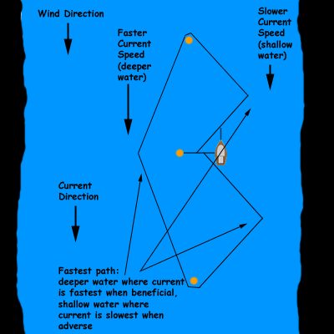

Downwind, we headed for the middle of the river where the current was fastest to help us get to the leeward mark as quickly as possible. We rounded, and sailed up the shore again to the finish.
The moral of the story? When the current is going against where you are trying to go, sail in the slowest flowing water as possible. If the water is flowing in the same direction that you are trying to go, you'll get there faster if you sail where the current flows the fastest.

